Hawaiin party

Venue : Aditya sarover , Gachibowli

Time : Please start from your homes at 5 pm and reach the venue by 5.45pm. Party will start at 6 pm sharp so that we wind up early.

Dress code : As illustrated below. Please scroll below to see dress code for Men, women, kids and pets. The best dressed Men, women, kids and pets get prizes.

Additional stuff to carry : Again illustrated below.



That’s the look for the boys. Bright Colourful shirts with shorts. Cool glasses with straw hats.

Footwear : Sandals / flip flops



Ladies dress code options



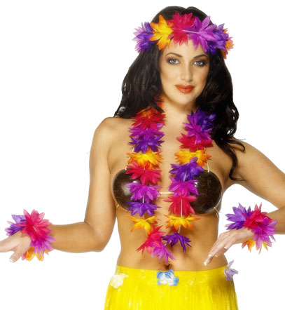

Length of skirt : Not shown here by design. Option is left to you dear ladies, but you all know what we all sunrise club men like!

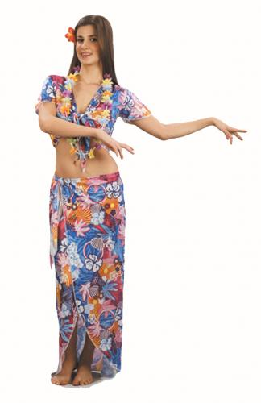

Bright colourful dresses with flowers in your hair.

Kids dress code

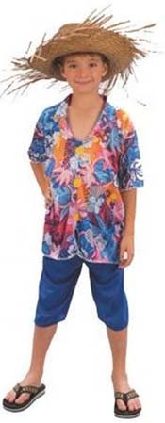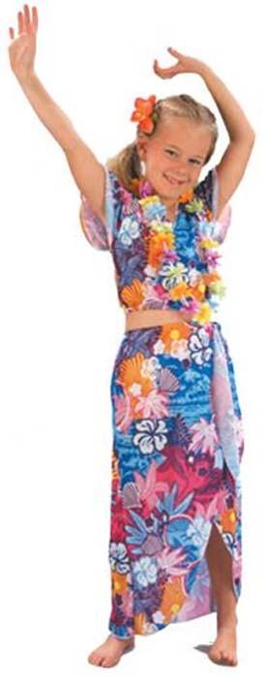

(Continued below)

Pets dress code

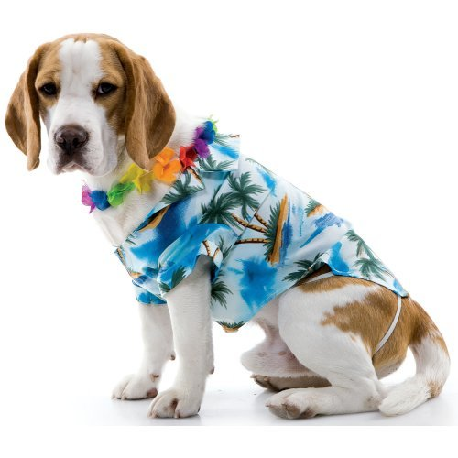

Additional stuff to carry

Beach balls

Hula hoops

Frisbee

Surf boards

